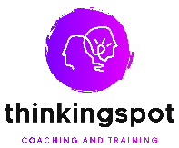
ThinkingSpot Coaching Evaluation Form

Questions

- What was your overall assessment of the programme/training?

Poor Satisfactory Good Very Good Excellent

- Which activities, topics or aspects of the programme/training did you find most interesting or useful?

- ________________________________________________________________________________________________

- ________________________________________________________________________________________________

- ________________________________________________________________________________________________

- Did the programme / training achieve the programme objective(s)?

Yes No

If you answered no, why?

- __________________________________________________________________________________________

__________________________________________________________________________________________

- Knowledge and Information gained from participation on this programme / training…

Met your expectations? Yes No Somewhat

Will be useful/applicable in my work and/or personal growth Yes No Somewhat

- How do you think the programme / training could have been made more effective?

- Please comment on the organisation of the event/online programme:

Poor Satisfactory Good Very Good Excellent

- Comments and suggestions that would be useful for the future (including activities or initiatives you think would be useful):

- Further Comments or suggestions:

THANK YOU!

